Name: | Maintain customer
Description: | The software allows the manager to carry out the maintenance (include, read, update, delete) of customers.
Actor: | Manager
Entry condition: | The actor selects the option Maintain Customer
Basic path: | - The system presents the customer registration screen containing: [PRO01]  - Name (editable)  - The options:  --- Search  --- New  --- Cancel  - The actor selects the option New [A01] [A02]  - The system presents a screen for entering the customer containing: [PRO02]  - Name (editable)  - SSN (editable)  - Address (editable)  - State (containing the list of the US states)  - The options:  --- Confirm  --- Back  - The actor informs customer data and selects the Confirm option [A03]  - The system verifies if the information is valid [BR01] [BR02] [E01]  - The system includes the new customer  - The use case is concluded  - The system returns to the home screen
Alternative paths: | [A01] The actor selects the Search option  - The system presents recovered customer, considering for each customer: [PRO03]  - Name (read only)  - SSN (read only)  - Address (read only)  - State (read only)  - The Edit option  - The Delete option  - The system presents at the end, the Back option  - The actor selects the Back option [A04] [A05]  - The use case returns to step 1 of the basic path.  [A02] The actor selects the Cancel option  - The use case is concluded  - The system returns to the home screen  [A03] The actor selects the option Back  - The use case returns to step 1 of the basic path  [A04] The actor selects the Edit option  - The system displays a form for editing the selected customer containing: [PRO04]  - Name (editable)  - SSN (editable)  - Address (editable)  - State (containing the list of the US states)  - The options:  --- Confirm  --- Back  - The actor enters customer data and selects the Confirm option [A06]  - The system verifies if the information is valid [BR01] [BR02] [E01]  - The system updates the customer information  - The use case is concluded  - The system returns to the home screen  [A05] The actor selects the Delete option  - The system confirms that the customer will be deleted  - The system excludes the customer  - The system returns to step 1 of the alternative path [A01]  [A06] The actor selects the option Back  - The use case returns to step 1 of the alternative path [A01]
Exception path: | [E01] Invalid registration information  - System displays message indicating the existence of invalid information.  - The use case returns to step 3 of the basic path.
Business Rules: | [BR01] All attributes are mandatory.  [BR02] The SSN must uniquely identify a customer in the system.
Data description
  Name | Type | Length | Mask
  Name | String | 50 | -
  SSN | String | 14 | XXX.XXX.XXX-XX
  Address | String | 50 | -
  State | String | 15 | -
Prototype: | [PRO01]  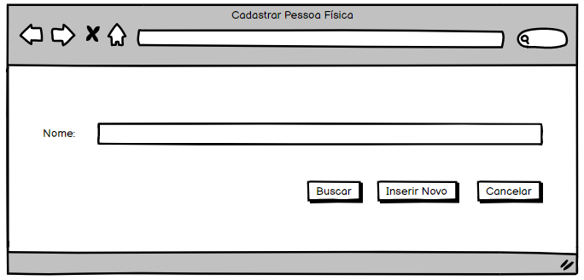  [PRO02]  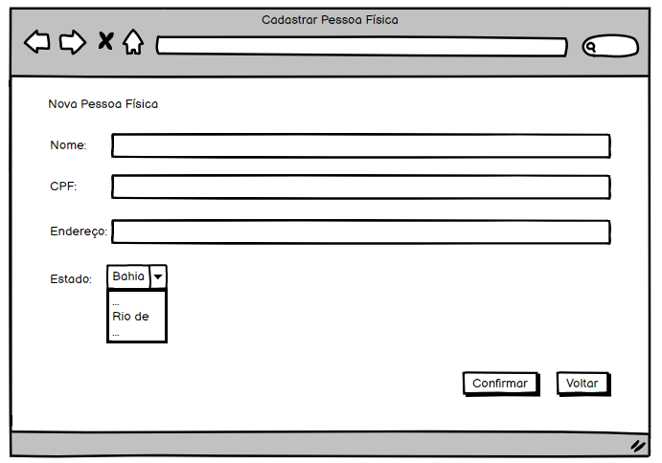  [PRO03]  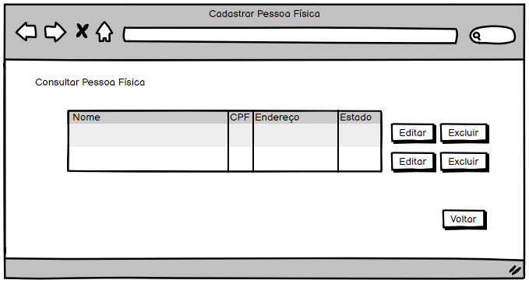  [PRO04]  